1. 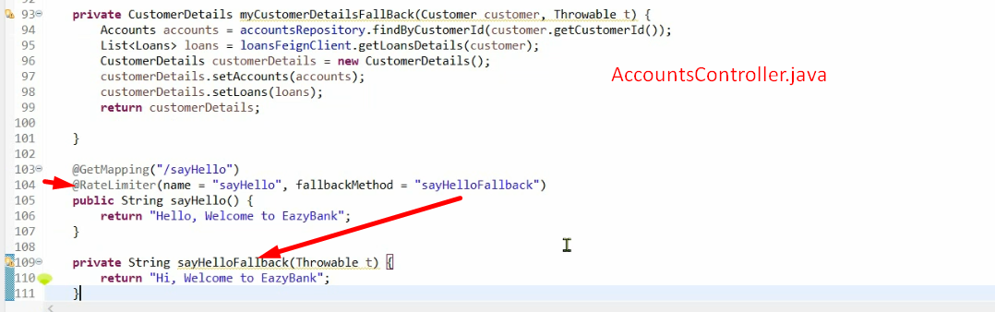
2. 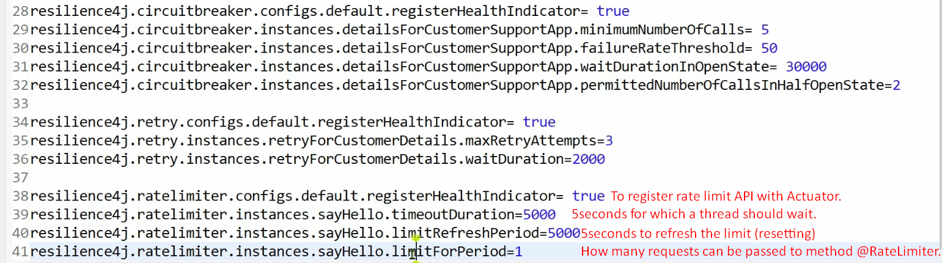limitForPeriod=1 request can be processed by method annotated with @RateLimiter.   
   If more than one request say 3 requests, then 2 requests would wait. After limitRefreshPeriod=5seconds, again one request can be processed by the method. If any request is in waiting queue for more than (timeoutDuration=5seconds), the that thread is terminated by throwing some exception.
3. They are called Resiliency Patterns.